Printing Your Certificate

If you have issues printing your certificate once you completed the survey or if you need to print your certificate at a later date, click on the link Print Certificate and then click on Sign in to generate Certificate.
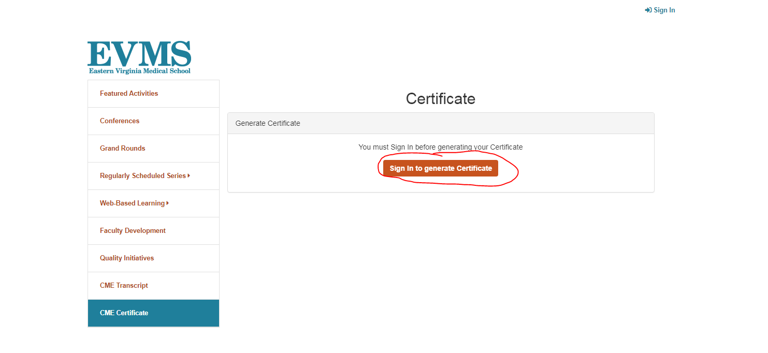
Enter your email address and password that you have already created.
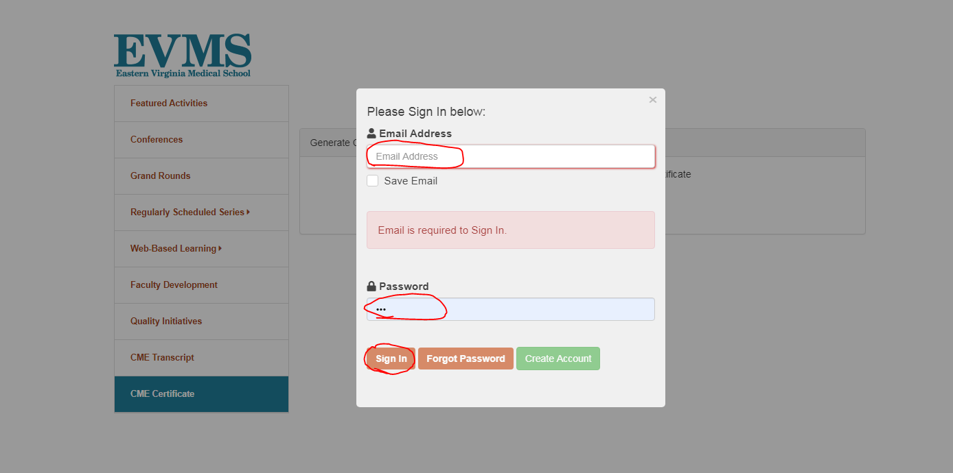

Once you have signed in successfully, click on the Continue button.
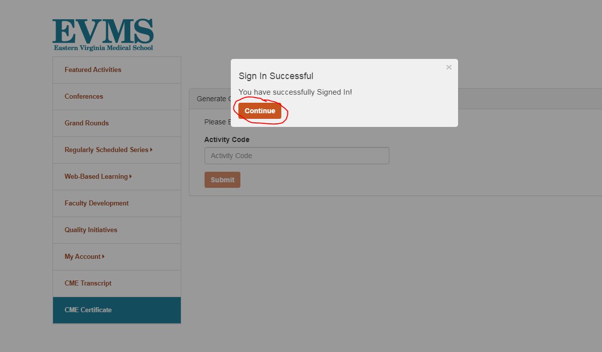
On the left hand side, click on My Account and then click on Credit History and Past Certificate.
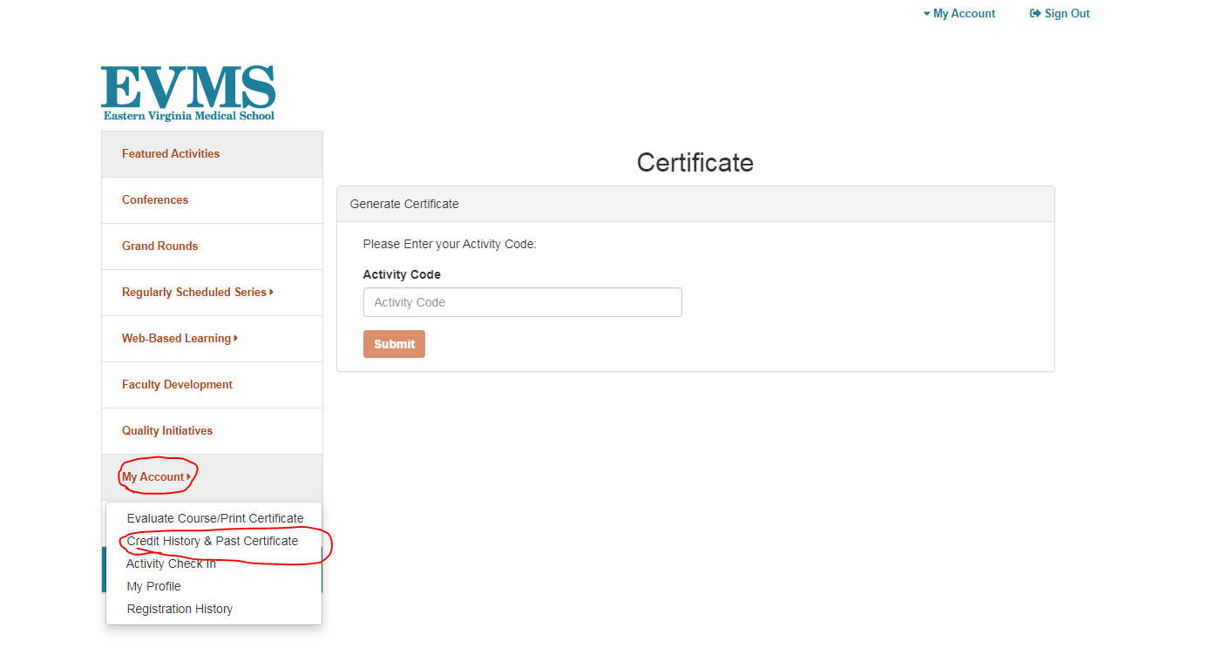

Under the Event Name, find the Event you need a certificate for and then click on Print Certificate.
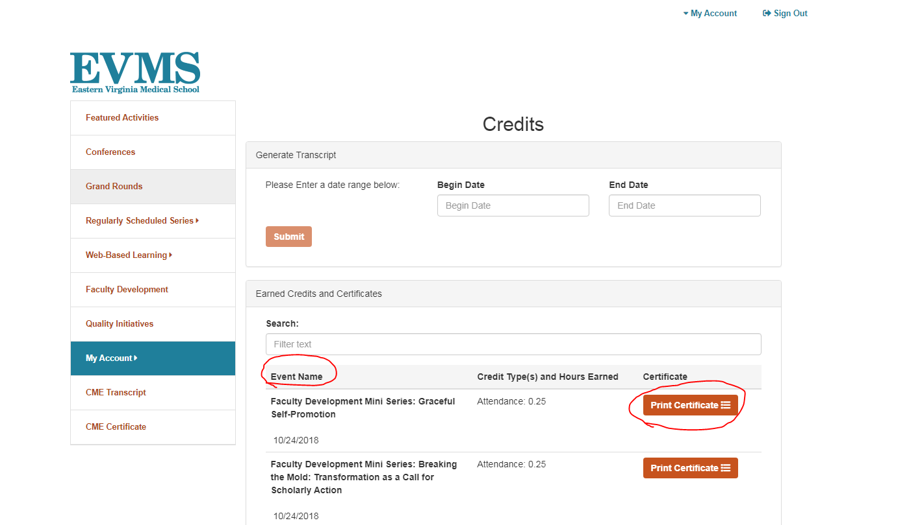
Your Certificate should generate and then click on Print Certificate.
