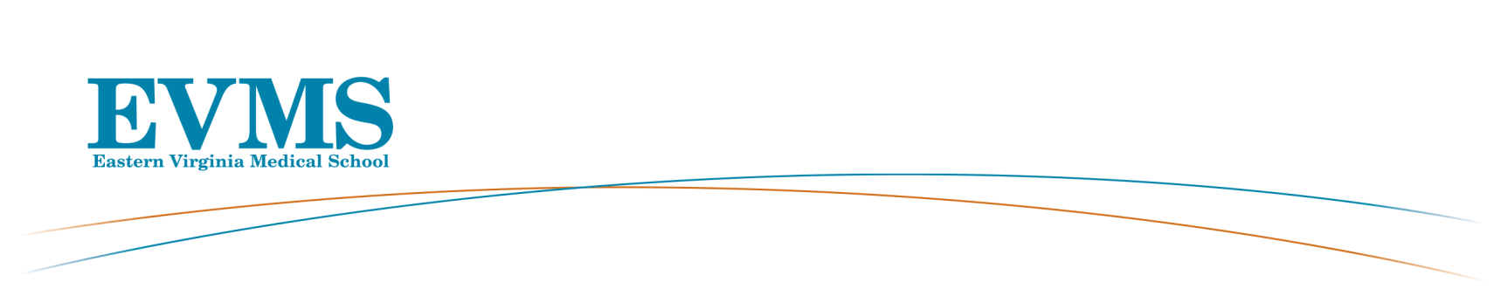
General Faculty Meeting
Roper Lecture Hall
October 8, 2019 5:00 - 6:00 pm

AGENDA

Welcome: Elza Mylona, PhD, MBA, Vice Provost for Faculty Affairs and Institutional Effectiveness

Approval of Graduates:

1. C. Donald Combs, PhD, Vice President and Dean, School of Health Professions
Programs:
Doctor of Biomedical Sciences

Physician’s Assistant Fellowship in Pediatric Urgent Care

Physician’s Assistant Fellowship in Emergency Medicine

Master of Physician Assistant

Master of Science in Art Therapy and Counseling

Master of Science in Biomedical Sciences – Research

Master of Science in Biotechnology

Health Care Management Certificate

2. Richard V. Homan, MD, President and Provost, Dean of the School of Medicine
Presents: Institutional Updates

3. Department Chairs Presenting New Faculty
Alison Dobbie, MB ChB, Chair, Family and Community Medicine
Michael S. Layne, MD
Karo Ohanian, MD
Robert Palmer, MD Interim Chair, Internal Medicine
Celine Chaya, MD
Barry J. Rittmann, Jr., MD, MPH
Aaron E. Mills, DO
Carolina Casellini, MD
Richard Conran, MD, Chair, Pathology and Anatomy
Carlee N. Demeter, MHS, MLS
Richard A. Gonzalez, PhD
Jacqueline K. Shaia, MS
C. Donald Combs, Vice President and Dean, School of Health Professions
Svetlana R. Mahan, MPA, PA-C
Mohan D. Pant, PhD

L. D. Britt, MD, MPH, Chairman, Surgery
Nicolas L. Bandy, MD
Charles K. Grigsby, MD

C.W. Gowen. MD, Chairman, Pediatrics
Sarah M. Parsons, PharmD
Maria P. Winn, MSN, FNP
Lester Johnson, MD, PhD, Chairman, Radiology
Dawn M. Hrelic, MD
Michelle Retrouvey, MD

4. Craig Derkay, MD, Professor, Otolaryngology-Head & Neck Surgery, President Faculty Senate
Presents: Faculty Senate Survey Results

5. Abby Van Voorhees, MD, Chair, Dermatology
Presents: Departmental Updates

Closing Remarks: Elza Mylona, PhD, MBA, Vice Provost for Faculty Affairs and Institutional Effectiveness

*Next General Faculty Meeting is February 11, 2020, 5:00-6:00pm-RoperAuditorium

Thank you for your attendance

