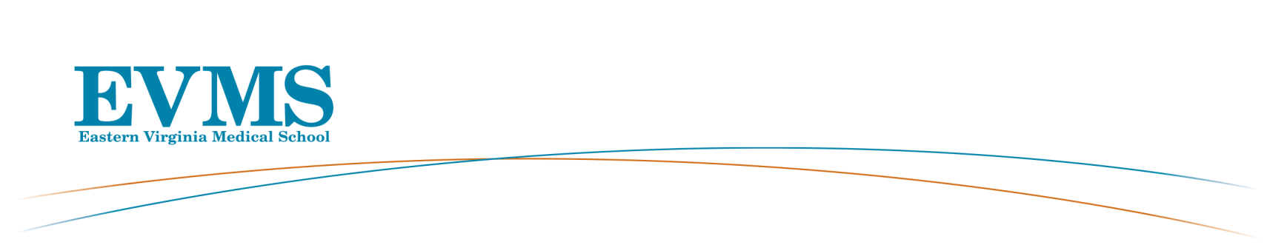
General Faculty Meeting
Roper Lecture Hall
October 9, 2018 5:00 - 6:00 pm

AGENDA

Welcome: Elza Mylona, PhD, MBA, Vice Provost for Faculty Affairs and Institutional Effectiveness

- Approval of Graduates:

C. Donald Combs, PhD, Vice President and Dean, School of Health Professions
Doctor of Biomedical Sciences
Haynes, Bronson
Phelps, Cody
Waseem, Tayab
Physician’s Assistant Fellowship in Pediatric Urgent Care
Biron, Emma
Frey, Patricia
Nguyen, Nguyen
Physicians’s Assistant Fellowship in Emergency Medicine
Mogensen, Karen
Master of Physician Assistant
Young, Kevin
Master of Science in Art Therapy and Counseling
Brown, Adrienne
Master of Science in Biomedical Sciences – Research
Booth, Elizabeth
Gauronskas, Phillip
Hitefield, Naomi
Kanda, Kevin
Kerns, Kimberly
Maynard, Kaitlyn (Jackson)
Moriarty, Alina
Northam, Nicole
Semeraro, Michele
Master of Science in Biotechnology
Gaafer, Omnia
Hairfield, Destiny
Whaley, Lindsey (Mitts)
Health Care Management Certificate
Eslinger, Karla (Brown)
Ongkeko, Russell

- Update from Richard V. Homan, MD, President and Provost, Dean of the School of Medicine

- Building Update
- Chair of Medicine Search
- Strategic Plan Update
OVER
- Chairs Present New Faculty
- Jerry Nadler, MD, Chairman Internal Medicine
Nancy D. Morewitz, MD
- Julie Kerry, PhD, Chairman, Microbiology and Molecular Cell Biology
Ronen Borenstein, PhD

4. Council for Faculty and Academic Societies (CFAS) update by Serina Neumann, PhD and
Anca Dobrian, PhD, FAHA

Closing Remarks: Elza Mylona, PhD, MBA, Vice Provost for Faculty Affairs and Institutional Effectiveness

*Next General Faculty Meeting is February 12, 2019, 5:00-6:00pm-Bank of America Auditorium

Thank you for your attendance

