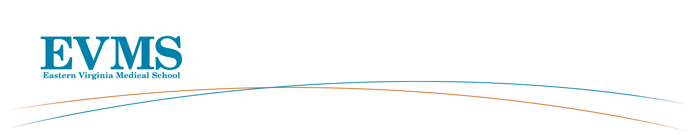
Professional Enrichment and Growth Grant
Academic Year 2024-2025

Requirements

Please submit a typed application using the following outline:
- Detailed Description of Proposed Activity – Please provide a detailed description of the proposed activity including where and when the activity will occur and if appropriate, with whom you will be working. The activity should be completed in the academic year 2024/2025
- Future Goals – Please describe your 5-year academic and professional goals and how this experience relates to them.
- Budget – Please detail how the grant money will be spent. Be as specific as possible. Note: Salary support, costs covered by an existing grant and/or professional dues/memberships will not be covered. University per diem meal/travel allowances will be used.

The completed application will include:
- Cover Sheet
- Checklist
- Typed application (described above - maximum 3 pages)*
- Applicant’s updated curriculum vitae
- Letter of support from the Department Chair – This letter should indicate the Chair’s support of the activity and a discussion of how it will enhance the applicant’s career and the department/ institution. It should also identify the activities from which you will be released during your involvement in the proposed activity (if applicable)
- Letter of support from the receiving institution (if applicable)
- Brochure of course/conference (if applicable)
- If you have received PEG grant funding in the past, please briefly describe the funded activity and how it benefitted your work with EVMS [one-page limit]

* If your application is to attend a Harvard Macy Institute course which has a requirement to complete a project, include a brief description of your project, its scope and impact on your work.

Timeline of the process:
- Submission of application is due on: April 30th at 5pm
- Review of applications by PEG Review Committee: mid-May
- Announcement of final award decisions is due: late May

How to submit the completed applications to: submit a combined pdf document according to the checklist to brocusrd@evms.edu

Faculty awarded a PEG Grant within the last two academic years (2022/23 and 2023/24) are not eligible to apply this cycle. You are welcome and encouraged to reapply if you were not awarded a grant.

Following completion of the activity, no later than 30 days, each awardee will submit a short, written report (2-page limit) summarizing the experience and outcomes to the Faculty Affairs and Professional Development. The structure of the report will be sent to you if awarded a grant.

Avoidable Obstacles to Being Awarded a PEG Grant
- The application is submitted late or is incomplete.
- The proposal is written poorly or contains multiple grammatical errors.
- The proposal is unfocused and lacks a level of clarity as to how the activity will contribute to career advancement.
- The proposal contains no assurance that the candidate can apply the learning experience or new skill upon her/his return.
- The budget lacks detail or is unreasonable.

