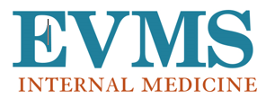Dear Colleagues,

Message

Volume 2, Issue 5

**IN IGNOTIS *“Into the unknown”***

***EVMS Internal Medicine Research Newsletter***

Welcome to Volume 2, Issue 5 of our Research Newsletter! On April 20, Dr. Liza Botros and Nargiza Kurbanova (MS2) led a research journal club on “Pre-Post Intervention Studies”. Looking ahead, on May 4, Dr. Botros will lead a journal club session on “Cross-over Randomized Controlled Trials”.

Scholarship

**PEER-REVIEWED PUBLICATIONS:**

*EVMS Faculty, Fellows, Residents*

1. Munir MZ, Bernstein E, Wadia R, Laskin WB. Pulmonary artery angiomatoid fibrous histiocytoma mimicking pulmonary embolism. *BMJ Case Rep*. 2023;16(3):e252872. Published 2023 Mar 29. doi:10.1136/bcr-2022-252872
2. Cundra L, Vallabhaneni M, Saadeh M, Houston K, Yoo B, D’Souza S, Johnson D. Immunomodulation strategies against COVID-19 evidence: key nutrients and dietary approaches. *The Journal of Exploration Medicine.* 2023;4:189–206. doi.org/10.37349/emed.2023.00133
3. Sausen DG, Basith A, Muqeemuddin S. EBV and Lymphomagenesis. *Cancers (Basel)*. 2023;15(7):2133. Published 2023 Apr 4. doi:10.3390/cancers15072133

*Community Faculty*

1. Brush JE Jr, Chaudhry SI, Dreyer RP, et al. Sex Differences in Symptom Complexity and Door-to-Balloon Time in Patients With ST-Elevation Myocardial Infarction [published online ahead of print, 2023 Apr 14]. *Am J Cardiol*. 2023;S0002-9149(23)00148-0. doi:10.1016/j.amjcard.2023.03.009
2. Brush JE Jr. Sex Disparities in Chest Pain Patients: Observations and Opportunities. J Am Coll Cardiol. 2023 Mar 14;81(10):946-948. doi: 10.1016/j.jacc.2023.01.006. PMID: 36889872.

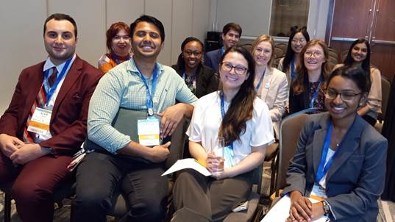

**ABSTRACTS, PRESENTATIONS, AWARDS:**

*Southern Gerontological Society Annual Conference*

Dunstan M. “Harnessing the Passion and Power of Student Volunteers” *Abstract Submission*

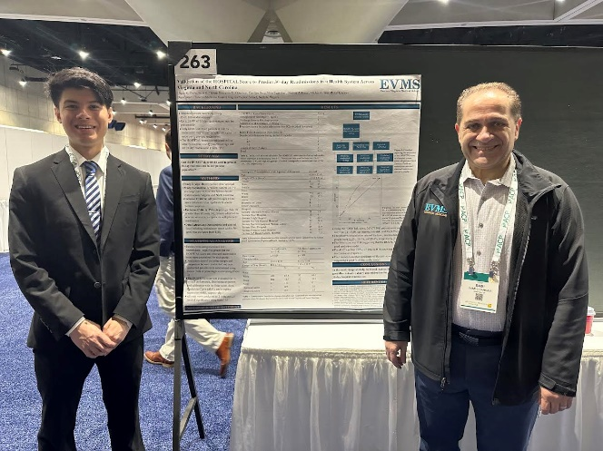Student-led conference topics: Beat of My Heart (Rajita Kanapareddy - MS2), Beond Clinic Walls & HealthWise (Sarah Mayo - MS1, Ally Nigro – MS1 , Alim Osman - MS1), Community Stroke Awareness (Hannah Stamos – MS2), Palliative Medicine (Nealy Minson – MS2), Street Health (Mary Anand – MS2), Students for the Advancement of Geriatric Education (Erica Watson, Medical Master’s Class of 2023)

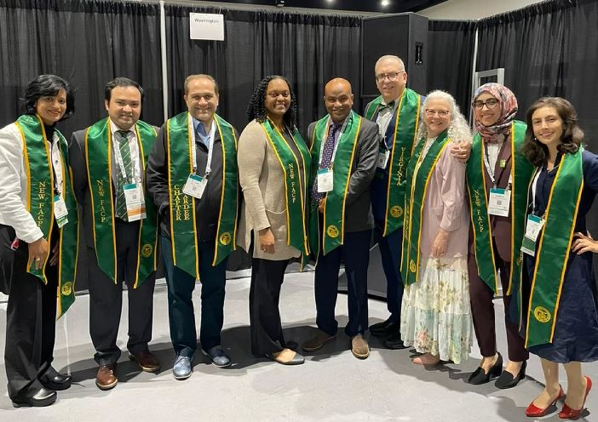Dr. David Johnson provided commentary on a recent MEDSCAPE article, “[CRC blood tests: A future without screening colonoscopies?](https://www.medscape.com/viewarticle/990465?reg=1)” and publication: [“New Colorectal Cancer Data Reveal Troubling Trends.”](https://www.medscape.com/viewarticle/990521)

Dr. Waleed Kassabo to present “The long-term relationship between α-klotho with all-cause and cause-specific mortality” at The Society of General Internal Medicine in Aurora, CO - May 10!

*American College of Physicians Conference – San Diego*

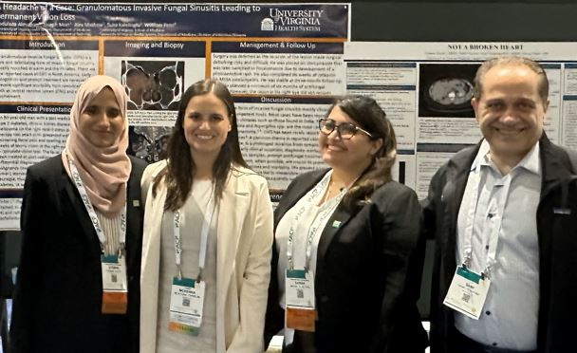Gagan Gupta (MS4) stands next to his poster “Validation of the HOSPITAL score to present 30-day readmissions in a health care systema across Virginia and North Carolina” with Dr. Sami Tahhan (Co-Investigator)

Dr. Sami Tahhan attends convocation as an ACP Virginia Chapter laureate recipient. Congratulations!!

Drs. Ayeman Basith and Sarah Al Allawi (PGY3s) stand next to their posters with Drs. Tahhan and Johnson.

Announcements

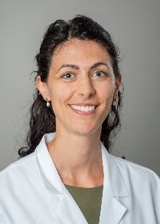 **RESEARCH WORKSHOPS & JOURNAL CLUBS:**

**May 4, 2023 – “Cross-Over RCTs” led by Liza Botros, MD, PhD**

Bonn-Miller MO, Sisley S, Riggs P, et al. The short-term impact of 3 smoked cannabis preparations versus placebo on PTSD symptoms: A randomized cross-over clinical trial. PLoS One. 2021;16(3):e0246990. Published 2021 Mar 17. doi:10.1371/journal.pone.0246990

**Hofheimer Hall, 5th floor**

**Large Conference Room**

**In-person or virtual option available**

Previously, we covered cost-benefit analysis, retrospective cohort design, and more! All welcome – no research experience necessary. Copies of the article are provided.

**GRAND ROUNDS:** In-person attendees receive lunch. Registration not required. Grand rounds are approved for 1.0 *AMA PRA Category 1 Credit.* Noon – 1PM in Waitzer Hall, Suite 300).

**May 3 –** “Suspecting Pulmonary Hypertension in the Dyspneic Patient” – Dr. Deborah Levine (Stanford)  **May 10 –** “Re-Imagining and Amplifying Research Excellence at EVMS” – Dr. Milton Brown (EVMS)

**May 17 –** “Hyponatremia is hard and it’s not your fault” – Dr. Topf (Oakland University)

**CALL FOR JUDGES! Internal Medicine Resident Scholarly Activity Day**

The 42nd Annual Scholarly Activity Day will be held **Friday, June 2, 2023 in Waitzer Hall, Room 100 at 12:30PM.**  Three faculty members preside as judges of senior resident research and QI scholarly presentations. Please email Deborah Lucas at [LucasDM@evms.edu](mailto:LucasDM@evms.edu) if you would like to serve as a judge.

**David C. Lieb, MD, FACE, FACP**

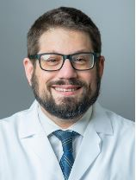**Please tell us about yourself:** I am an endocrinologist in the Division of Endocrine and Metabolic Disorders at EVMS. I grew up in Richmond, and did my medical school and endocrine fellowship at the University of Virginia. I’ve been at EVMS since 2009, and in addition to my research activities, I serve as the Associate Chair for Education for the Department of Medicine, and I am the program Director for our Endocrinology Fellowship. I have an amazing wife (Emily), and 3 ridiculous boys (Spencer, 16; Elliot, 14; Henry, 10). When I’m not at work I enjoy reading comics, listening to podcasts, watching comedies and spending time with my family wandering around Ghent.

**Describe the studies you are currently involved in:** I am currently the PI for the Western Tidewater UNITED project – a 4-year program funded through the Dean’s Office at EVMS that involves screening individuals for diabetes in Western Tidewater Virginia. We are also working with colleagues at Sentara to identify ‘super-utilizers’ of health care – those with diabetes that have frequent admissions to the hospital or the ER. We plan to develop an intervention aimed at identifying barriers to care in this population, and reducing hospital use. I am also developing a clinical registry for our Adult Transgender Endocrine Clinic, and am working with colleagues to develop a survey involving medication rationing.

**Do you have any research mentors? If so, what have they taught you?** I have been fortunate to have many mentors in research. My research mentors during endocrine fellowship and in my earlier career here at EVMS – Drs. Robert Carey (at UVA) and Jerry Nadler, taught me how to frame and ask research questions, and how to present data in abstracts, posters and oral presentations. My current research mentors include Drs. Qayyum, Siraj, Parson and Casellini – all of whom have had significant experience in performing clinical research, and have much to teach me. Dr. Siraj has reminded me of the importance of prioritizing / protecting time for research, for reading and for deep thought. Dr. Qayyum is helping me to understand how to ‘think like a researcher’, as opposed to thinking like a clinician.

**What skills do you hope to develop as a researcher moving forward?** My current research projects and interests involve improving clinical outcomes for the underserved, and reducing health care disparities in Hampton Roads. I hope to learn more about developing community advisory boards to develop trust and collaboration with those for whom we provide care and wish to understand, and am also interested in community-based participatory research methods and qualitative research methods.

**What is your favorite hobby, a recent book you’ve read, or TV show you’ve watched…and tell us what you enjoy about it!** I recently saw writer and poet Clint Smith on The Late Show with Stephen Colbert. He’s an amazing writer – and he was promoting his new book of poetry Above Ground. He spoke about his recent work of non-fiction – How the Word is Passed: A Reckoning with the History of Slavery Across America. I bought it and couldn’t put it down. In the book he describes his travels to seven different locations in the U.S. (including Monticello) and one in Senegal, on the western coast of Africa – "to understand how each reckons with its relationship to the history of American slavery." I highly recommend it - I'm still thinking about the lessons Mr. Smith's travels and insights taught me.